

Jam Buddies

Project Report

DT265

Higher Diploma in Computing

**James Byrne**

**Paul Kelly**

School of Computing

Dublin Institute of Technology

**15/01/18**

Abstract

This report details the process of developing Jambuddies , an android application that helps facilitates communication between irish amatuer musicians . It allows users to view each others details and send messages in real time . It was developed using a firebase JSON database . The aim of the project was to help young musicians find one another using just a phone and the application .

Declaration

I hereby declare that the work described in this dissertation is, except where otherwise stated, entirely my own work and has not been submitted as an exercise for a degree at this or any other university.

Signed:

___________James Byrne ______________

James Byrne

15/01/18

Acknowledgements

There are a number of people I’m grateful for and owe thanks to who helped me complete this project .

Firstly Paul Kelly my project supervisior, who gave solid advice when I needed it and helped keep on track to complete the project . You will make a great lecturer .

Jarome Casey who helped me learn about android and made a 9am class enjoyable .

Jonathon Mc Carthy who helped me learn about Java and Who helpped me grow as a programmer .

My family who helped to push me to do this course in the first place and who have given me support through it .

Table of Contents

Table of Contents

1.Project Statement 6

Overview of Project 6

Project Challenges 7

2.Research 7

Technologies considered 7

*C# web applications* 8

*Android applications* 8

Choosing a development environment 9

Market research 10

*Existing apps in the area.* 10

*BandFriend* 11

*Fleeber* 12

12

*Conclusion* 13

Personal background 13

Survey 13

Question 1 Results 14

Question 2 Results 14

Question 3 Results 14

Question 4 Results 15

Question 5 Results 16

3.Approach and Methodology 17

Scrum 17

Waterfall 19

Rad – Rapid Application Development. 19

4.Design 20

a.System Requirements 20

*Use Case diagram* 20

*Wire Frames* 20

b.System Design 21

*Jam Buddies Class Diagram* 21

*Jam buddies Sequence Diagram* 21

*Firebase Json Database .* 23

System Architecture (Minimal working prototype) 23

5.Evaluation and Testing 24

6.Issues and Risks 25

7.Implementation 26

8.Project Plan 29

9.Conclusion 30

10.Bibliography 32

11.Appendices 35

­

# **Project Statement**

## **Overview of Project**

This project is an Android Application for musicians to use, which will allow them to create a profile, search for other users and chat with them. The profile should allow a user to give enough information about themselves that other users know if they want to talk to them. A key feature needed is the ability to link to YouTube or sound cloud so that users can hear each other. This also serves a way to start a conversation by responding to a user’s music, which helps users have a better experience on the app. Each person’s data shall be stored in a firebase database.

The inspiration for Jam Buddies stems from personal experience. For my undergrad, I studied music in D.I.T. and as part of that often I would be required to play with others for exams or gigs. Often the process of finding other musicians was tedious as many musicians were doing multiple projects, and finding them was largely done through word of mouth. So, if I wanted an instrument not being studied by someone in the college itself, I was dependant on someone knowing someone. This experience has led me to the idea of creating an android application to enable musicians to connect and communicate.

The initial stages were focused on deciding on a technology for the application. I decided that android would be suitable. Android was appealing for several reasons; Firstly, the information available makes it easy to follow android best practices. Secondly, I have android studios installed and own multiple android devices, so I understand android from the user’s perspective. Finally, it would allow me to apply knowledge learned in Java and android classes and enhance my ability as a developer.

**Project Objectives**

The purpose of the project is to develop an application that allows the user to complete the following functionality.

* Create an account and login with email and password.
* Create and edit a profile page.
* Search for other users.
* View another user’s profile page.
* Send messages to other users.

From a user’s perspective, they should be able to do the following.

* Create a profile that lets them express relevant information.
* Search and filter other users
* Be able to listen to other’s music
* Be able to chat with other users (in a way similar to WhatsApp)

## **Project Challenges**

One of the main Challenges faced was learning how to develop a working android application with this level of functionality. In class, simpler apps had been looked at, but learning how to create an app that let users create a profile, search and communicate though web messages, was outside of my ability. I didn’t know how to implement any of this functionality, I did understand the solid design principles and I knew how to learn to do it.

Another challenge was dealing with Firebase and a Json based database. I Had no experience with this. Key functionality of the project was linked to saving data in a Json, retrieving and displaying that data to a user, filtering the data displayed to the user.

Another challenge was time. As well as completing this project, I was also studying three other modules each with their own assignments. I had no prior knowledge of the technologies used before starting, so, much of the time was spent learning about and how to use the required technologies.

# **Research**

## **Technologies considered**

Once the idea had been chosen and requirements had been understood, it was time to consider which technology to use. The possible considerations were a mobile app (so android or IOS) or else a web app in c#. As the course has classes in android and C# it made sense to use as much existing knowledge to implement the idea while under pressure to complete the project.

### *C# web applications*

C# is a programming language developed by Microsoft. It’s like java, being object oriented and strongly typed.  ASP.net is a Server-side web Application framework. Its open Source and developed by Microsoft. If developing jam buddies as a web application, the ASP.NET MVC Framework would be used. The Model-View-Controller (MVC) architectural pattern separates an application into three main components: the model, the view, and the controller (Msdn.microsoft.com, 2017). The model is generally responsible for things like business, validation or database logic. The view is responsible for what the user sees, and it contains the HTML mark up. The controller is responsible for the interactions between the user and the application. By separating the application into three components, the business logic can be reused in another interface or another application. Visual studio is the integrated development environment (IDE) for C#.

The benefits of developing a web application include; being more accessible through multiple mediums (desktop, IOS and android) and it is easier to maintain across multiple platforms. However, it is limited in how it can utilize the devices hardware. Although native apps tend to be faster and more efficient as “*they work in tandem with the mobile device they are developed for. Also, they are assured of quality” (*Viswanathan, 2017*),* android has standards all developers writing apps on the platform follow. This helps users and developers to know what to expect from an android app.

### *Android applications*

*“The Android operating system is a multi-user Linux system in which each app is a different user” (*Fundamentals, 2017*).* Every android application in android studio will have gradle dependency files, java files, XLM layouts and an android manifest, as well as various resource files. The manifest is the first place the device looks when try it runs the app. It tells the system the minimum api needed to run it, user permissions the app requires, such as internet access, and it also *“declares hardware and software features used or required by the app, such as a camera”.* (Fundamentals, 2017)

Apps are built from app components, of which there are four different types: activities, services, broadcast receivers and content providers. Activities can be thought of as functionality linked to a screen, they work together to form a “*cohesive user experience*” (Fundamentals, 2017). In WhatsApp for example, to send a picture to a contact the app is launched, and it displays a contacts list activity. If a contact is selected it stops the current activity while launching a chat activity. If a user selects the camera icon, stops the chat activity and launches a photo activity. The user can take a photo and it launches an edit photo activity. If a user clicks the send button it restarts the chat activity and passes the photo in as a message and waits for the user to hit send.  Activities keep *“track of what the user currently cares about (what is on screen) to ensure that the system keeps running the process that is hosting the activity”*. (Fundamentals, 2017)

Services are components that work in the background. If a person plays music on Spotify while using another app, they are using a service. A service doesn’t have to stop when another activity is launched.

Broadcast receivers allow “*the system to deliver events to the app outside of a regular user flow”* (Fundamentals, 2017). For Example, an alarm on an app, the alarm can be triggered even if the app is not running. They can be from the system such as a low battery notification or from app.

Content providers “*supply data from one application to others on request*.” (www.tutorialspoint.com, 2017)

### **Choosing a development environment**

When writing the android application, the main options for the development environment are Android studios or Xamarin. Android studios was Google’s recommendation, but it was worth considering the alternative.  Xamarin is a development platform acquired by Microsoft. It uses C# to create apps for all mobile environments. It allows for code sharing but to do this a *“platform specific layer”* (Altexsoft.com, 2017) of code is needed, so some java or kotlin is still needed. Applications tend to be larger in size on Xamarin.

Android studio was the chosen development environment for the project.  It uses Java and XML. It also uses gradle which is a build system which helps manage dependencies. Android Studio is based on the Jet Brains’ IntelliJ IDEA. It is the official IDE for the android platform. The largest contributing factor in this decision was having more exposure to the software as it was used in class. This meant that less time would be spent trying to understand the IDE. That means more time can be spent on working on the app itself.

**Choosing a database**.

Firebase is a NoSQL database and is only available as a cloud service. It is a typical JSON tree database similar to many other NoSQL databases like MongoDB, Redis, or Casandra (Park, 2017). Firebase is integrated into android studio. It’s used for a variety of tasks such as authentication and databases. It makes the development process easier. All a developer must do is write a small amount of code and add a dependency into gradle in their app. Its biggest benefit is it is in real time. So if there is chat functionality users can see the messages as soon as they are sent. *“When you point your app to the proper data source in Firebase, it will retrieve the data in real-time. This will save a tremendous amount of custom development time”* (Park, 2017). As firebase is only available as a cloud service the developer doesn’t need to worry about server side as its handled by google.

SQLite is an Open source SQL database that can be stored both on disk and in memory. Android allows for built in SQLite database functionality. It supports relational database features without the needing to establish connections like JDBC. SQLite supports the data types Text, String, integers and doubles all other types must be converted to one of these before being added to an SQLite database. *“It supports dynamic typing transactions, full-text search, single-writer/multiple-reader access, efficient range queries (useful when storing geographical data), and shared caching”*

(Roukounaki, 2014)

Some of the advantages to SQLite include. Content *“can be accessed and updated using powerful SQL queries, greatly reducing the complexity of the application code”* (UDHAY, 2014). It reliable as it has been widely used since the year 2000. It is stable for cross platform databases, so if a desktop version was developed the database could be copied and viewed on a machine with a different architecture.

The reasons for choosing android was due to a personal desire to improve my skill and knowledge in that area. As the course has a class for android development that uses android studio, it seems like a good decision to use the project to enhance and expand my knowledge from the class.

## 

## **Market research**

## *Existing apps in the area.*

After beginning market research, several apps that do similar things were discovered. Each of these where downloaded and tested purely from the user’s perspective

The first being bandfriend which was *“designed from the ground up to be a mobile application.”* (BandFriend, 2017). It is available on both android and IOS. This means a wider pool of musicians to choose from which makes the application more valuable.

### *BandFriend*

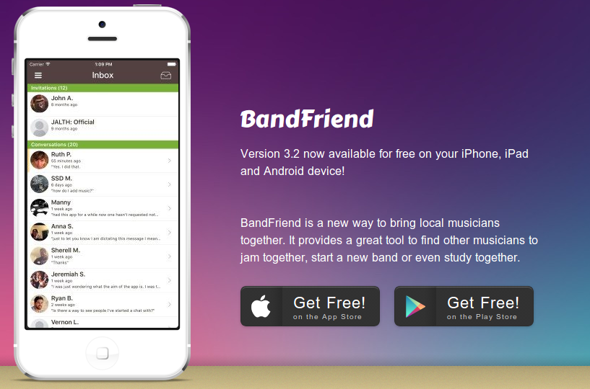

It allows users to create a profile, but they can sign in via Facebook profile. It allows users to link sound cloud as well as having YouTube integration.

After downloading it and setting up an account. It takes the user to an edit profile screen. This contains a series of menus (Your musical styles, your skills, your interests, your instruments, your links, your bands your likes and personal information). Each menu option launches another activity in which you tap a series pre-set constrains to describe your musical self. Once a profile is configured a user can search either by musicians or by bands. Each giving the user a wide array of choices (by skill, by musical style, by skill, by location, people you may know).

It offers a variety of choice to the user but doesn’t leave much room for the user to express themselves in their own words, such as preferred genre, it’s just clicking pre-set options. As it’s an American made app it doesn’t consider genres such as trad music, this could be an issue as its limiting. This could be eliminated by allowing user input in another category. The user interface is simple and intuitive, there are feature they implement which I had planned to. Such as navigating via the menu icon in the top left corner.

Many reviews stated it has potential but it’s unknown, as a musician for years I was unaware of it. Only when attempting to build a similar application I became aware of its existence.

### *Fleeber*

### 

Fleeber allows a user to view another user’s location on the app before signing up. When a user signs up they can create a profile or user Facebook or google. The next stage is to pick a profile type (musician, DJ, band/artist, product, service, place, explorer) which you can add more to later should a user fall into multiple categories. After picking a musician type, a user inputs an instrument, styles and location. They can now start searching for other musicians.

The search menu contains a search bar and underneath it two tabs a wall and a map. Fleeber tries to mirror Facebook, allowing users to have a wall, but it is not clear, after 30 minutes of using it, how to link videos or audio. The search function uses google maps. It’s not intuitive or a pleasant experience for the user. Despite making profile based in Dublin most of the news feed is in Portuguese.

A problem with this app is it has a very small user base in Ireland, its showing less than 100 users in Leinster. This app is not helpful for finding musicians. Another problem is it uses google maps which shows where the users house is located. If a user lists their instruments and equipment, often worth tens of thousands, they are advertising to be robbed. If they just asked for the area they lived in it would avoid this. Overall this app tries to accommodate too many different user groups and doesn’t serve any single one well.

### *Conclusion*

Both apps examined lack a large enough user base in Ireland to be useful in Ireland, as they are American centric. Band friend is a much better app, both to use as a musician and its overall superior design. Part of the reason is it has a singular focus which it does well. If you are looking for people to play music with, use this app. This is the model for an app, this project is aiming for.  The fact several companies have tried to create an app that fills the role of using technology to connect musicians suggests it is a problem multiple people have experienced. No app or service has been successful enough in this area that it becomes the standard. In Ireland all the products tested so far are not effective.

## **Personal background**

As a music student and musician, I have played music in many settings and have often been looking for others to complete a line up. Sometimes it was for an exam, others it was a band or project. It’s common to look for other musicians through word of mouth but there is no widely used resource to help musicians with this problem. For dating people use tinder, for property people use daft, but no such base exists for Irish musicians to communicate. This is where the idea for this app comes from.

However, in Ireland, people enjoy word of mouth because if friends know a person you a looking for, they can tell you about them. In terms of working musicians, it is a small country. Therefore, it’s a possibility that for professionals an app like this would never work in this country. Word of mouth has a level of trust with it. My friend x introduces me to his friend y and I will subconsciously extend some of the trust I extend to my friend x to his friend y.

## **Survey**

In order to check the interest in the app idea a survey was conducted. The questions along with a breakdown of the responses are in the following pictures.

### Question 1 Results

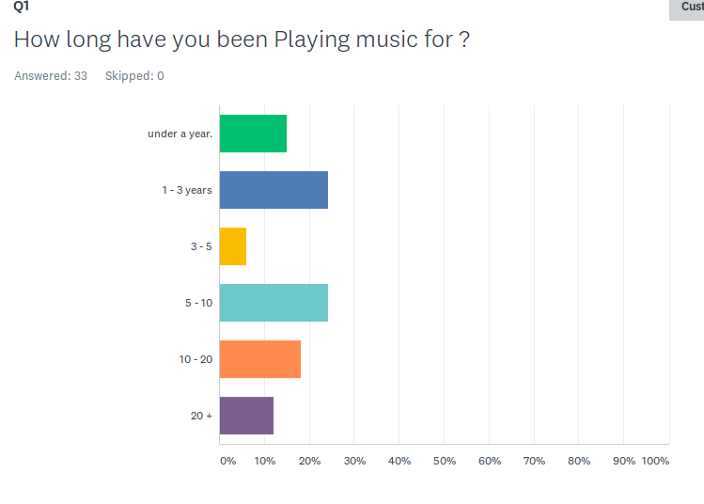

### Question 2 Results

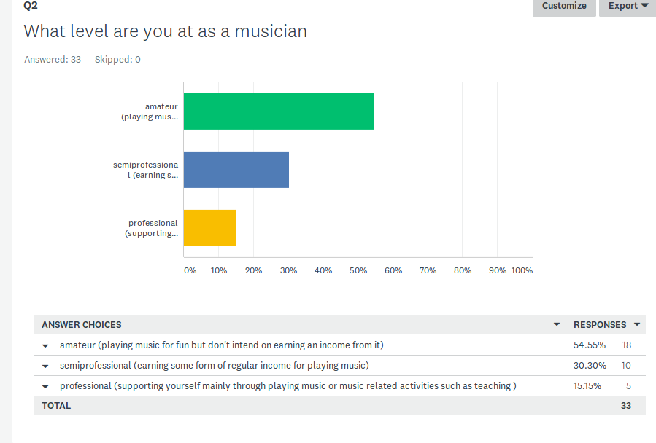

### Question 3 Results

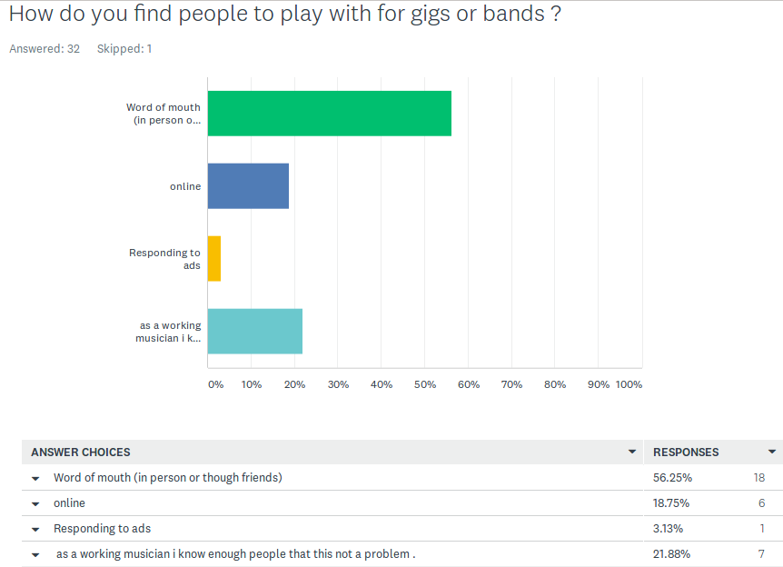

### Question 4 Results

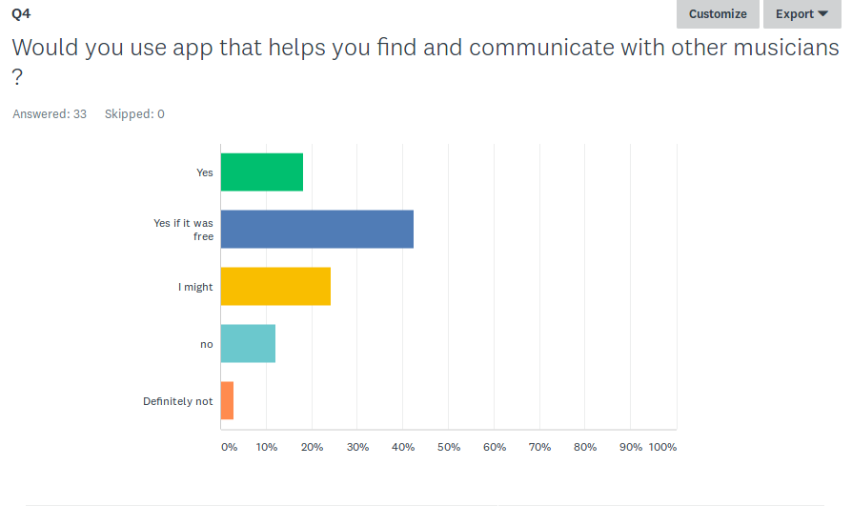

### Question 5 Results

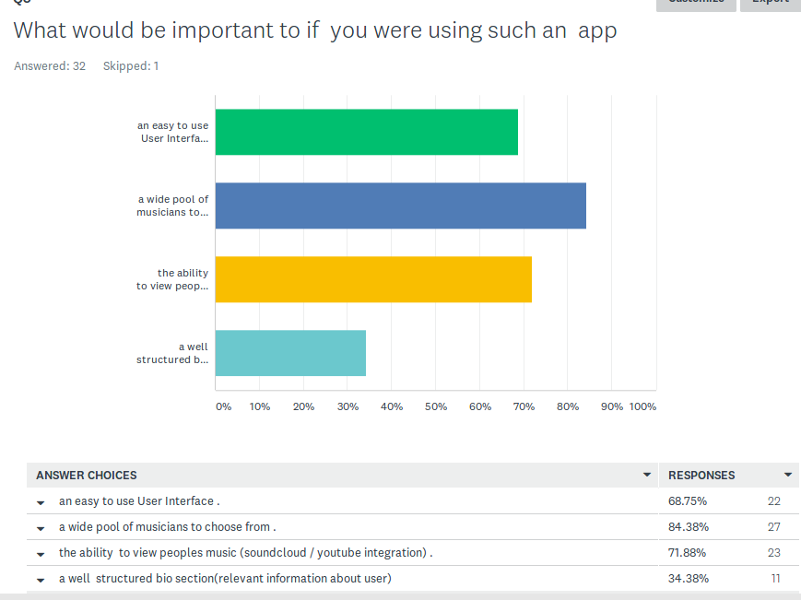

After posting the survey to music related Facebook groups the link was open for two days. It received thirty-three responses.

There was a correlation between the experience level and the interest in the idea.  People who answered professional tended to answer I might or no to question. Which leads to the conclusion that the app is better suited towards an amateur market. The vast majority of people who answered amateur or semi-professional for question two. Answered   either *“yes”*, “*yes if it was free*” or *“I might*”. Despite the relatively small sample size, it is a clear indication that more inexperienced players find the app more appealing than experienced ones.

One would assume experienced players are more likely to already have a wide network of musicians to choose from and there would have less need for such an app. This sample size is far too small to make any definitive claims. The survey could also have been influenced by personal bias in terms of the pre-set responses.

# **Approach and Methodology**

When considering which methodology to use for the project it was important to research which ones would be most effective for my aims. The main methodologies considered were agile (scrum), waterfall and rad. It was decided that scrum was the most suitable and the project supervisor recommended Zen hub, software that integrates with git hub.

### **Scrum**

Scrum is an agile development practice in use today. Core scrum concepts include product backlogs, sprints, team roles and burn down charts. In scrum features are written from the user perspective and are known as User Stories. The collection of these user stories is called the product backlog. It can be thought of as a wish list of all the features you would like your product to implement. To plan a release, a team starts with product backlog. Each of the user stories are broken down into tasks and those tasks are given standardized time estimates either in hours, days or weeks. With each task given a time estimate, they can then be grouped into a series of sprints. These sprints work towards your release.

The sprints are used to monitor how long tasks are expected to take. If sprints are behind schedule, it’s an indication that the project won’t be ready by the estimated release date. Progress of a project is measured on a burndown chat. It’s an effective way to see how much work is left to do in a sprint or release. The slope of the burndown chart shows the rate of productivity for each day.

ZENHUB software that integrates with GitHub, allows the implementation of a scrum approach into the project. It allows for the creation of scrum back log, with user stories, spikes epics and sprints. All work for the project could now be estimated and managed accordingly. Even writing this section was first an issue in an epic. In this way, the workload can be tackled as a series of small problems that are parts of larger chunks of work which when put together form a complete project

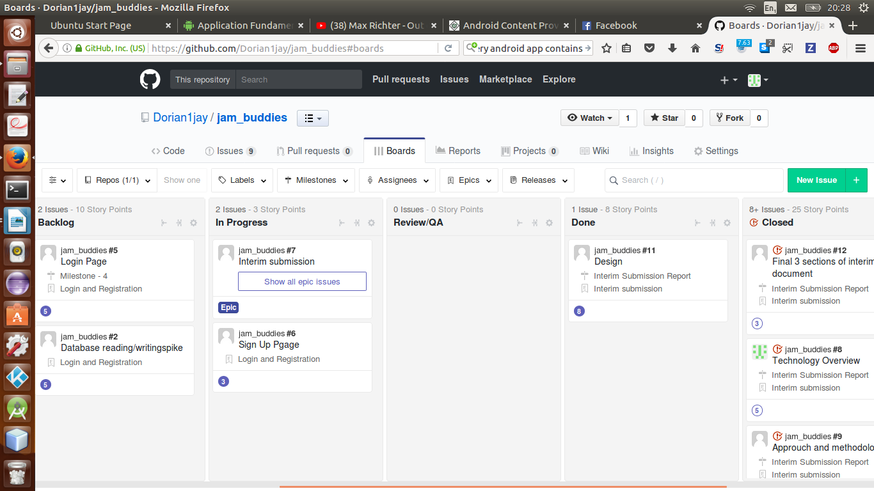

*Zen hub boards on github*

No single approach will work in every case. Even Scrum has advantages and disadvantages. Some of the disadvantages include; *“Scrum often leads to scope creep, due to the lack of a definite end-date”* (Chandana, 2017). This is not such a problem as this project has due dates. *“Adopting the Scrum framework in large teams is challenging”* (Chandana, 2017). This will not be an issue for this project. Some other issues say it works better with more experienced members but the same is true for every approach. In adopting a scrum approach for a solo project, a large portion of the potential problems associated with scrum will be avoided as they are team related.

Some of the advantages include “*Agile Scrum can work with any technology/ programming language but is particularly useful for fast moving web 2.0 or new media projects.”* (Adell, 2013). And *“The overhead cost in terms of process and management is minimal thus leading to a quicker, cheaper result.”* (Adell, 2013) Again much of the advantages scrum won’t apply as this is a student project done by one person. It is more about learning to implement the approach.

The real advantage of adopting scrum for a solo project is that it allows a single person to act and think in several different roles. Like in Edward de Bono’s six thinking hats *“If you never change your mind, why have one?”* (De Bono, 1999). A developer can try to view the project from a scrum master perspective or an end user perspective. Each perspective has different priorities, and all are important to deliver a quality project on time.

### **Waterfall**

It takes a linear approach from start to finish and is difficult to change once a project has begun. Therefore, planning and analysis are crucial for this method to be successful. Waterfall can be broken up into six stages that happen linearly; idea, analysis, design, development, test, final product.

The waterfall methodology lacks the ability to be adaptive. If when developing a product, the team needs to change the approach, this methodology makes that difficult. If a project is large scale and the outcome must be predictable with great accuracy, it is an effective methodology. It’s often used in construction.

It would not be suitable for a project of this type, as students are the developers they will probably make a wrong decision during the project such as choosing a database that won’t work for their project. For the project to be successful the approach needs to allow for students to go back and fix mistakes. Waterfall does not allow for this.

### **Rad – Rapid Application Development.**

How fast can a developer go from idea to testable prototype. RAD uses minimal planning in favour of rapid prototyping. *“In the RAD model, the functional modules are developed in parallel as prototypes and are integrated to make the complete product for faster product delivery. Since there is no detailed preplanning, it makes it easier to incorporate the changes within the development processes.”* (www.tutorialspoint.com, 2017)

To use RAD, the system must be modular, so that prototypes can be created separately and then linked together. For this project a rad approach could be problematic, so it was not adopted.

# **Design**

## **System Requirements**

### *Use Case diagram*

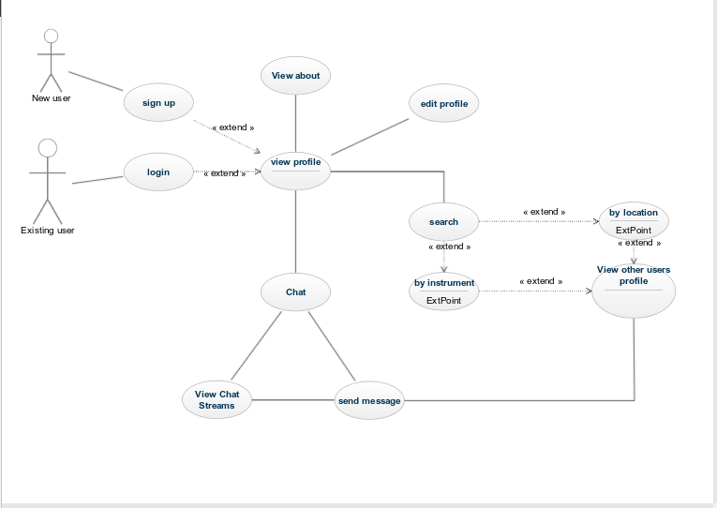

### *Wire Frames*

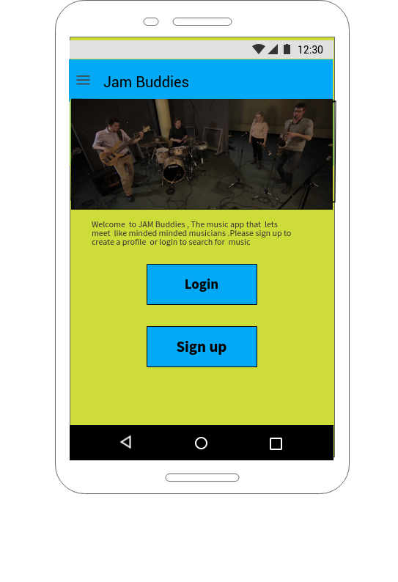

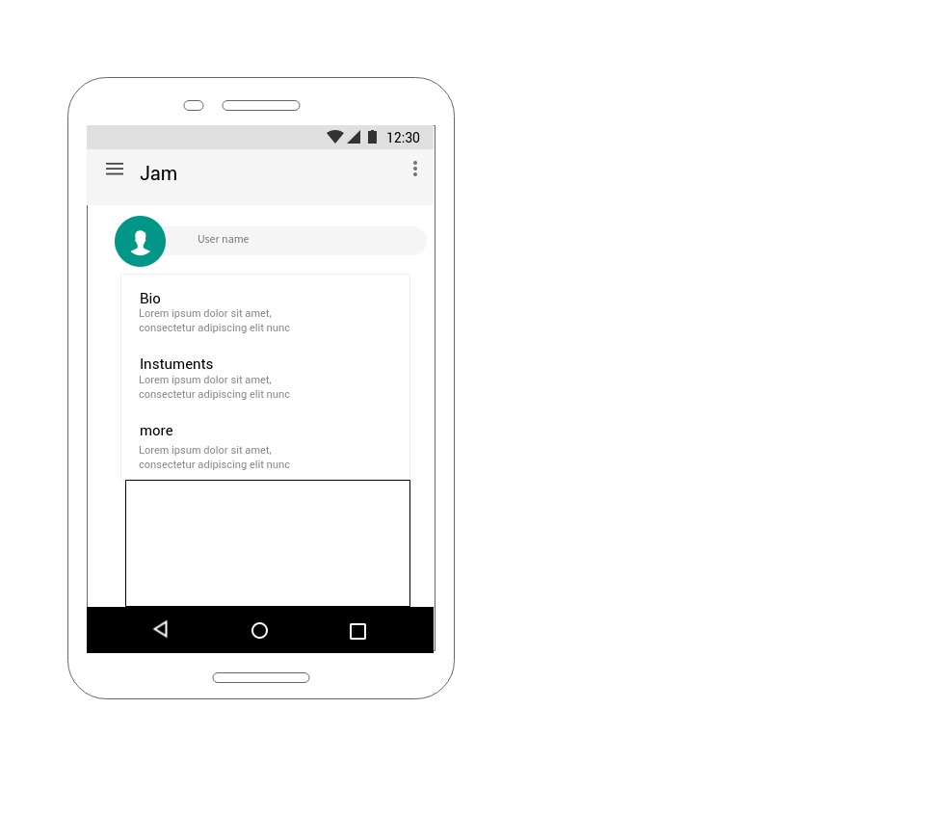

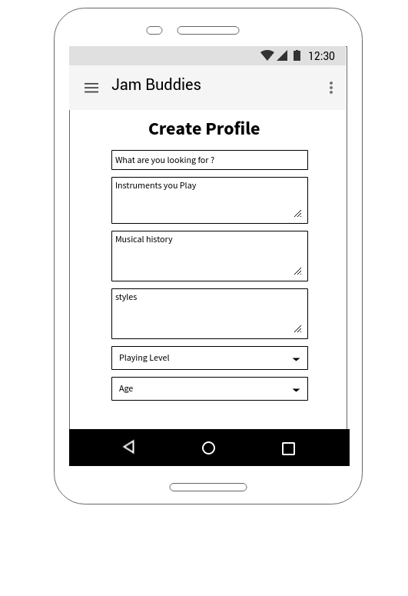

## **System Design**

### *Jam Buddies Class Diagram*

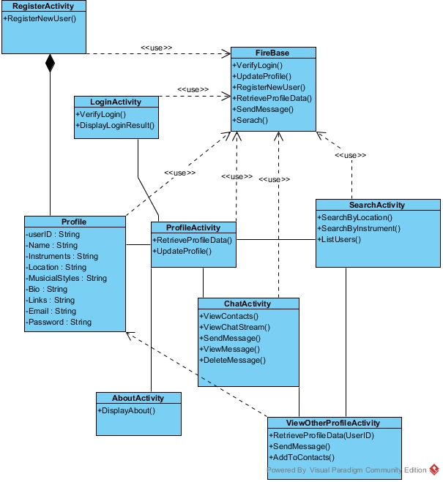

### *Jam buddies Sequence Diagram*

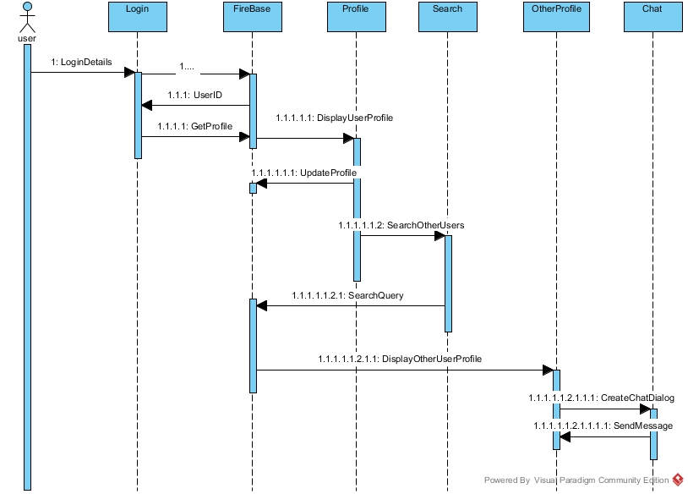

### 

### *Firebase Json Database .*

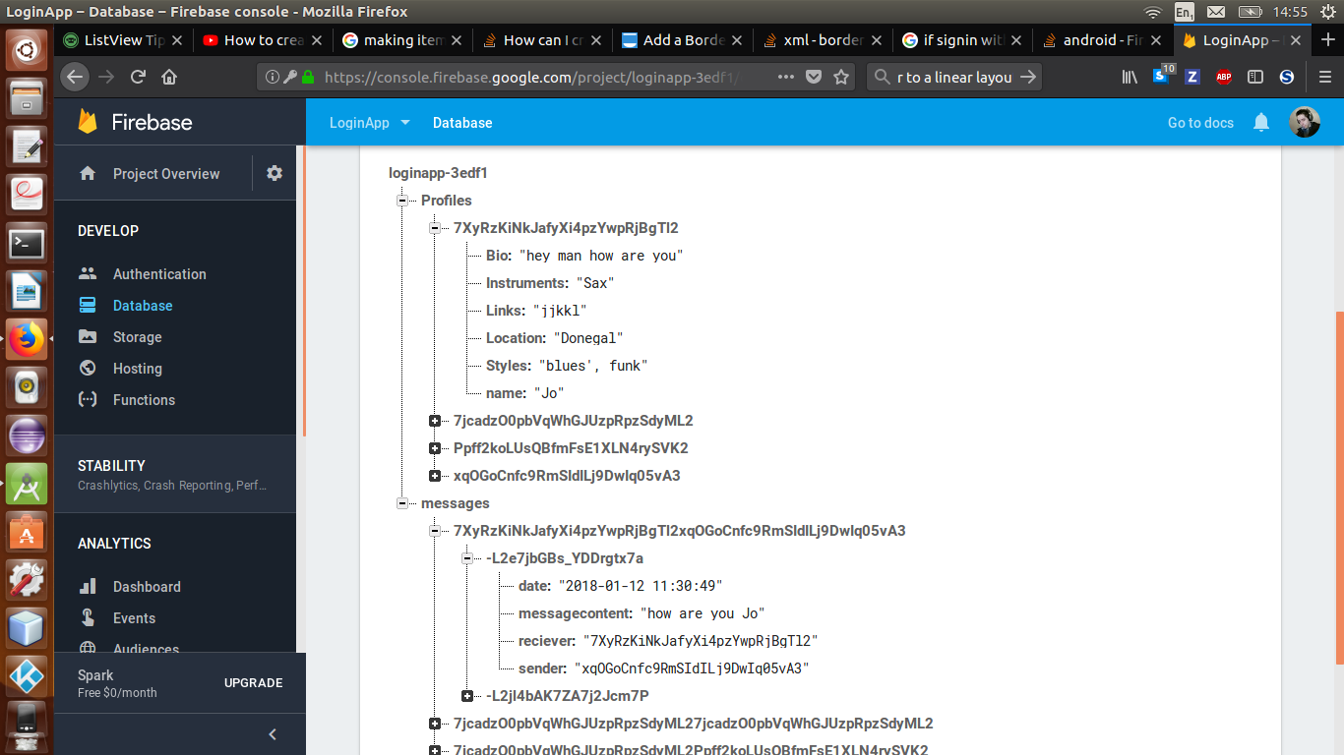

### **System Architecture (Minimal working prototype)**

Part of process of completing this project was creating prototypes for parts of functionality that could cause problems.  The prototypes were created as part of the epics they are a part of. The Login and registration epic contained a prototype (LoginApp) for logging in to a firebase database and adding a name to it. The user first had to be authenticated by entering the correct email and password. This launched another activity where the user could enter a name and add it to a Json database. This was done to better understand how to work with firebase. Each of the epics contain prototypes to allow for a better understanding of how to implement sections of functionality. Future prototypes include Searching and displaying data from a Json file and Chatting between users.

# **Evaluation and Testing**

Initially my goal for evaluation was to compare the finished app to project objectives. Does it allow users to sign in, create a profile, search for other users, view their profile and communicate with one another. In terms of evaluating the results , Although not all functionality has been implemented , the search aspect , the Application does what it was intended to do when the idea was conceived. It facilitates communication between two people after they have seen each other's profile .The design has been altered slightly because of the browsing users instead of searching for them .

In order to try and get feed back for the application . Some family and friends installed and tested out and provided feedback , Some of which influenced the future improvements the conclusion section. Overall the feedback was positive however some bugs and issue were identified . One issue was that sometimes the contacts page does load the contacts immediately . If you return to the menu and press it a second time they will be. I'm sure this is due to the delay of having to fetch the contacts through firebase .This is a problem that would have been good to address.

In terms of testing. A black box approach was the main method used. Unit testing had been planned but was not implement due to time constraints.While developing the application , each activity was tested to make sure it functioned as it was intended.

# **Issues and Risks**

In doing any project, there are risks and issues. Only by identifying and being aware of them can we try to avoid them. The issues in this project are interdependent upon one another; the most prevalent issue is time. This affects all aspects of the project

The first is the time constraint; there is a date in early January the project must be completed.  Along with the project, there are assignments and obligations for multiple classes, although they help expand knowledge, they take up time, which could be spent working on the project. There is a difficulty in time management, getting everything completed on time.

How this risk will be mitigated is through weekly meetings with the project supervisor, so that work can be assigned on a weekly basis. Progress and problems are discussed. The project supervisor also has access to the boards in GitHub and can view the issues, epics and sprints as a scrum approach was adopted for the methodology. Each of the major steps in the project was broken up into epics. These include the interim submission, chat functionality, and login and registration.  Each epic contains several parts with time estimates. This way each problem is broken down into a series of smaller problems and are easier to solve.

As Android is a new technology for me, there will be a learning curve and this process takes time. The project is an opportunity to improve in an area. There will be times where code will be incorrect, and time spent trying to debug and find errors.

How this risk will be mitigated is through extensive research in the form of books, classes and tutorials as well as discussion of problems with lecturers and the project supervisor. The more coding experience in android and research into the documentation the better the chance problems can be solved without external assistance. If a problem exists that is taking a considerable time to solve, external advice will be sought out from lecturers and the supervisor.

As android Studio is an IDE, it could be problematic. For example, gradle the dependency manager has caused problems. As android studio is running on a Linux machine, there was an issue with the emulator not running because it didn’t have certain C++ files which it needed to run it, this problem seemed specific to Linux. Fortunately, these problems were solved and debugging experience was gained.

A problem that can persist is bugs between versions, while updating version 2.3 to 3.0 of android studio certain functionality in projects that previously worked can stopped working. This takes time to understand and fix. Multiple students in the course have experienced similar issues with the IDE. There is no way to avoid it only to try to debug problems as they occur.

# **7.Implementation**

The implementation of the can be broken down sequentially in terms of functionality. Login in and sign up, creating and editing a user profile, displaying user information to other users and Messaging functionality.

The login and sign up features both used firebase authentication.

When a user first signs up they are required to enter an email and password, this is then used to generate a unique user ID which is used to interacted with the firebase database.

The sign-up activity requires a user to enter an email, password and password confirmation. Validation checks are performed on the user’s input to check if any of the fields are empty, if the passwords match and if the email address is valid. If any of these checks fail the user receives a toast message explaining the problem. Once a user enters valid inputs a toast displays a “User Successfully Created” message.

The Login Activity displays email and password inputs. Once a firebase user id is created, the user must enter their password and email combination in order to access the app. The login activity contains also validation checks from the ValidateHelper class.

Once a Login is successful, an intent is started that takes the user to a menu activity.

The menu activity is a navigation screen which allows the user to the view profile activity, edit Profile activity, and contacts activity.

**Edit profile**

The edit profile screen contains a combination of text inputs, spinners and buttons. The user must enter a name, a short biography section, a description of their musical styles, any links to their music, set a location and an instrument. Validation is present here to make sure none of the fields are empty. A user presses the save data button. Their profile data is then saved in the fire base database as a user profile object. It is saved within the profiles child under their user ID as a series of key value pairs. The user id the user can access at any point lets them alter the database solely affecting their data. Once this is complete a toast message is displayed to the user saying “the users’ profile has been updated “and all the text fields are reset.

The Spinners for location and instruments were chosen over text inputs the make the search functionality easier, by limiting the search terms to a list of counties and a list of instruments. It made the process of querying the firebase database easier. It meant a user couldn’t make a spelling mistake or give in valid input. Search functionality was not implemented due to time constrains.

The idea was to query the profiles section and retrieve a list of user ids that matched the criteria either the chosen instrument or the chosen location. If the list was not empty, contact objects would be generated displaying a condensed profile view of each user matching criteria. Upon clicking a contact item. The full profile view would then be displayed.

**View Profile**

The view profile activity displays the user profile data as a series of items in a list view. It does this by retrieving the current users ID and a database reference “MyRef”. MyRef allows access to a data snapshot through an add value event listener. A data snapshot is an object that contains data from the firebase database. This means a path can be specified. Such as retrieved the value of the (user id) child (name). In the data snapshot the show data method is called.

To retrieve each of the data strings a user profile is created. Each of the pieces of data is retrieved. An array list is then created, and the pieces of data are added to it. They are added as they will appear to the user so included are strings that act as Labels such as “Name: James”. The array list is then passed to an array adapter with a layout for each item in the list view. The list view then sets the adapter displaying each of the pieces of data in the users’ profile.

**Contacts**

The contacts activity displays a list of contacts in a list view. Each item contains a name, location, instrument and a user id. The contact can be considered a mini user profile. The reason for this was the user needed a way to browse through the existing users and filter through them, so a user could select who they wished to communicate with.

The contact activity works by getting a database reference, then the data snapshot. It loops through each of the profiles the database and creates contact objects for each of them. The contacts are added to an array list which is added to an array adapter that adds them to the list view. The list view contains an on item click listener. Which displays the view profile activity for the contact item that’s pressed. The User id is passed as an extra through the intent.

The view other profile is basically the same as view profile except it has a send message button. It populates the profile view using the User id passed through in the Contacts intent. The send message button takes the user to the Chat activity.

**The Chat activity**

The chat activity allows two users to send messages into the database. Both users can view the other messages in real-time. Once a user finds a profile they are interested in the goal was to enable communication between them.

The chat activity contains a list view to display messages and a message box which a user can use to write a message with a send button beside it.

The current users’ id is stored and the users’ id from the profile that launched the chat activity was also stored. Both ids are used to deterministically generate a conversation id. This is done by adding both ids to an array list, sorting them and then returning them. This ensures that any two combinations of user ids will produce the same conversation Id. It avoids having to use two separate id combinations which would double every message and take up unnecessary space in the database.

Once the conversation Id exists, two database references are created. One to retrieve the other user’s name from their profile and another that will be the location for the messages.

Once a user types a message and clicks send. The onclick listener is triggered. The date is retrieved and formatted and stored as a string. A new message object is created and added to the database using a push notification. The message text box is then reset.

When a message is added, the on child added method is entered. This reads in the new message and gets the sender user id and the message content. The sender id is then checked against the current user id to see if the match.

The add message method displays messages in a text friendly way so blue for the current user’s messages with the gravity set to the left. For other users their messages are displayed in orange with the gravity set to the right. This way a person can effortlessly tell who sent what message.

# **8.Project Plan**

The major difference between the project plan and the project is the lack of search functionality. This was due to time constraints, some problems in the project took longer than anticipated to solve and there was also a problem with other modules assignment being due in certain times that hindered the progress of this project.

Initially there was a plan for a more elaborate user interface, based on a series of tutorials on YouTube. However, in trying to create a similar design, a few problems were encountered that delayed progress. That is why the project is located under the title of login app instead of jambuddies on GitHub. It was decided that to make progress a simpler approach had to be taken. So, functionality was incrementally added to the prototype instead of trying to create something more complex. That experience was important as it helped convey the value of solving smaller problems instead

The overall flow of the project is different because of the lack of searching. Instead of searching for a user that has fits a certain criterion, like a guitar player, all users are displayed and can be viewed and interacted with. Adding searching would be essential for a larger number of users. However, given the small number of current users it doesn’t pose a large problem.

Greater project management skills would have improved this project. Zen hub helped by allowing for a clear way to break down the project into manageable chunks. There were times I had to abandon working on this project to complete other assignments. The shifting between languages and frameworks also had its problems. At times I found it overwhelming, but reflecting on the structure laid out in the scrum boards was helpful for limiting the scope of focus and allowing the project to progress.

# **9.Conclusion**

One of the key things I gained from this project was a better understanding of android. From the activity life cycle to the core components of an android app. The project was a way to test and improve my java and android programming abilities. Becoming familiar with Firebase for authentication and its use as a data base was another benefit. It was also my first time using a non Sql database and learning about Json style databases.

It was the first experience using an agile methodology. Although the project management skills could have been improved, the scrum approach helped limit the scope of what the current focus was. This area is a personal weakness of mine, but using boards to display the work load helped demonstrate the value of a systematic documentation of the work that has to be done.

One of the most valuable lessons I learned from the project was the value of breaking problems down as small as possible. This approach not only makes a problem seem more manageable, but also improves the speed at which the problem can be solved.

Once this approach was adopted, I felt more confident as a developer, as no matter the problem a solution could be found. Rather than focusing on solving the entire problem, it was more effective to focus on the halfway point. For example, instead of focusing on messaging functionality as a whole, what problems do I need to solve to store data, to read data, to create a unique conversation id? Although all are necessary for messaging functionality to work, by seeing the smaller problems inside a larger one, I only had to tackle them, and the larger ones were solved as I went. It was an extremely rewarding experience.

Future Improvements

There are many ways the project could have been improved. Below is a list of some I would have liked to do had there been more time to complete the project.

* Adding search functionality. This would also include altering the current design, so a user would have to add another user to their contacts list before being able to communicate. It would limit the amount of profiles a user would be exposed to while navigating to the chat section. The ability to sort the users contact list would also be beneficial.
* Adding unit testing. Although the project was tested extensively using a black box approach, time was a factor and so although unit testing was planned, it was left out as there wasn’t enough time to complete everything.
* Adding profile pictures would help improve the app, as it is a common part of many phone applications the user has come to expect.
* Allowing for users to be authenticated with Facebook or Gmail.
* Allowing members of the intended userbase to try out the application and getting outside feedback.
* Altering the chat functionality to enable pictures to be sent.
* Changing the user interface to have a more modern look and feel.
* Improved accessibility. Making the talk back function work with jambuddies. Making the application more accessible for users with other languages.
* Adding an onclick listener to the links item of the profile page so that when the user clicks it, it opens and loads the URL in the link.

# **10.Bibliography**

**Your Bibliography:**Adell, l. (2013). *Benefits and Pitfalls of using Scrum Software Development Methodology*. [online] Belatrix Software Development Blog. Available at: http://www.belatrixsf.com/blog/benefits-pitfalls-of-using-scrum-software-development-methodology/ [Accessed 17 Nov. 2017].

**Your Bibliography:**www.tutorialspoint.com. (2017). *Android Application Components*. [online]Availableat:https://www.tutorialspoint.com/android/android_application_components.htm [Accessed 17 Nov. 2017].

**Your Bibliography:**Msdn.microsoft.com. (2017). *ASP.NET MVC Overview*. [online] Available at: https://msdn.microsoft.com/en-us/library/dd381412(v=vs.108).aspx [Accessed 17 Nov. 2017].

**Your Bibliography:**BandFriend. (2017). *BandFriend · Your iOS and Android app for Musician Classifieds and more*. [online] Available at: http://www.bandfriendapp.com/ [Accessed 17 Nov. 2017].

**Your Bibliography:**Chandana (2017). *Scrum Project Management Pros and Cons | CSM Training*. [online] Simplilearn.com. Available at: https://www.simplilearn.com/scrum-project-management-article [Accessed 17 Nov. 2017].

**Your Bibliography:**De Bono, E. (1999). *Six thinking hats*. Boston: Back Bay Books.

**Your Bibliography:**Fundamentals, A. (2017). *Application Fundamentals | Android Developers*.[online]Developer.android.com.Availableat:https://developer.android.com/guide/components/fundamentals.html [Accessed 17 Nov. 2017].

**Your Bibliography:**YouTube. (2012). *Intro to Scrum in Under 10 Minutes*. [online] Available at: https://www.youtube.com/watch?v=XU0llRltyFM [Accessed 17 Nov. 2017].

**Your Bibliography:**Jamin, B. (2016). *Reasons Not To Use Firebase*. [online] Crisp Insights. Available at: https://crisp.chat/blog/why-you-should-never-use-firebase-realtime-database/ [Accessed 17 Nov. 2017].

**Your Bibliography:**Park, A. (2017). *Firebase Real-Time Database Benefits & Overview - Anexinet*. [online] Anexinet. Available at: http://www.anexinet.com/blog/firebase-real-time-database-benefits-overview/ [Accessed 17 Nov. 2017].

**Your Bibliography:**Roukounaki, K. (2014). *Five popular databases for mobile*. [online] developereconomics.com. Available at: https://www.developereconomics.com/five-popular-databases-for-mobile [Accessed 17 Nov. 2017].

**Your Bibliography:**www.tutorialspoint.com. (2017). *SDLC RAD Model*. [online] Available at: https://www.tutorialspoint.com/sdlc/sdlc_rad_model.htm [Accessed 17 Nov. 2017].

**Your Bibliography:**Altexsoft.com. (2017). *The Good and The Bad of Xamarin Mobile Development*. [online] Available at: https://www.altexsoft.com/blog/mobile/the-good-and-the-bad-of-xamarin-mobile-development/ [Accessed 17 Nov. 2017].

**Your Bibliography:**UDHAY (2014). *What is SQLite?*. [online] Android Tutorial Blog. Available at: http://programmerguru.com/android-tutorial/what-is-sqlite/ [Accessed 17 Nov. 2017].

**Your Bibliography:**Viswanathan, P. (2017). *Should You Develop a Native App or a Web App?*. [online] Lifewire. Available at: https://www.lifewire.com/native-apps-vs-web-apps-2373133 [Accessed 17 Nov. 2017].

**Your Bibliography:**YouTube. (2017). *What is the Waterfall Methodology?*. [online] Available

at: https://www.youtube.com/watch?v=lYR3KNTE9SU [Accessed 17 Nov. 2017].

# **11.Appendices**

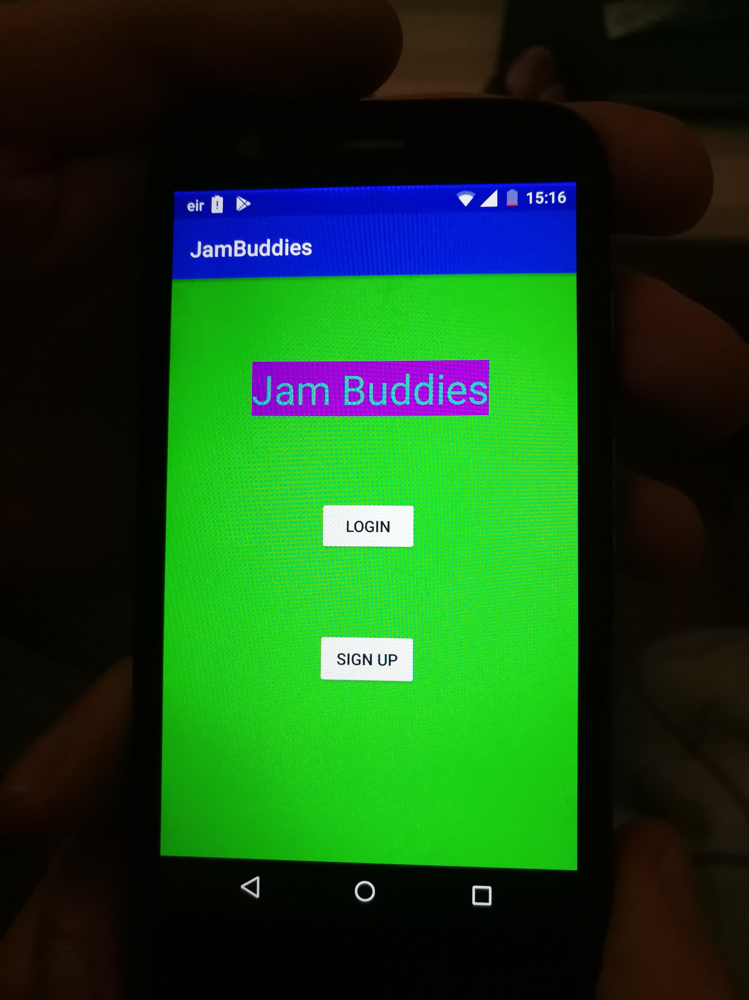First Screen

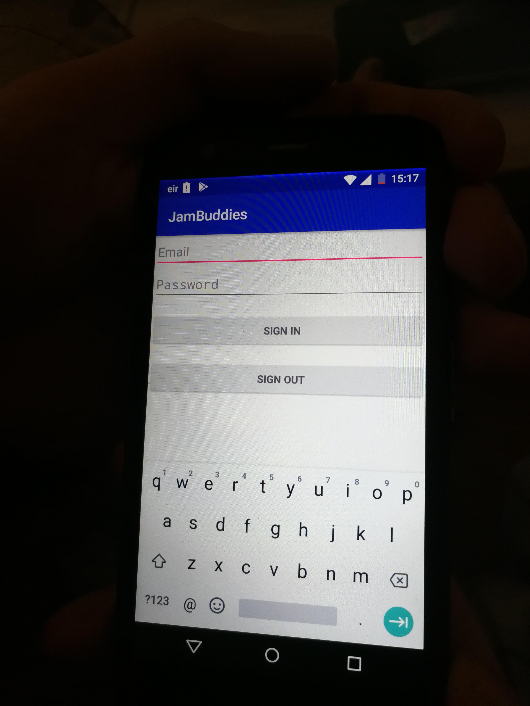Login

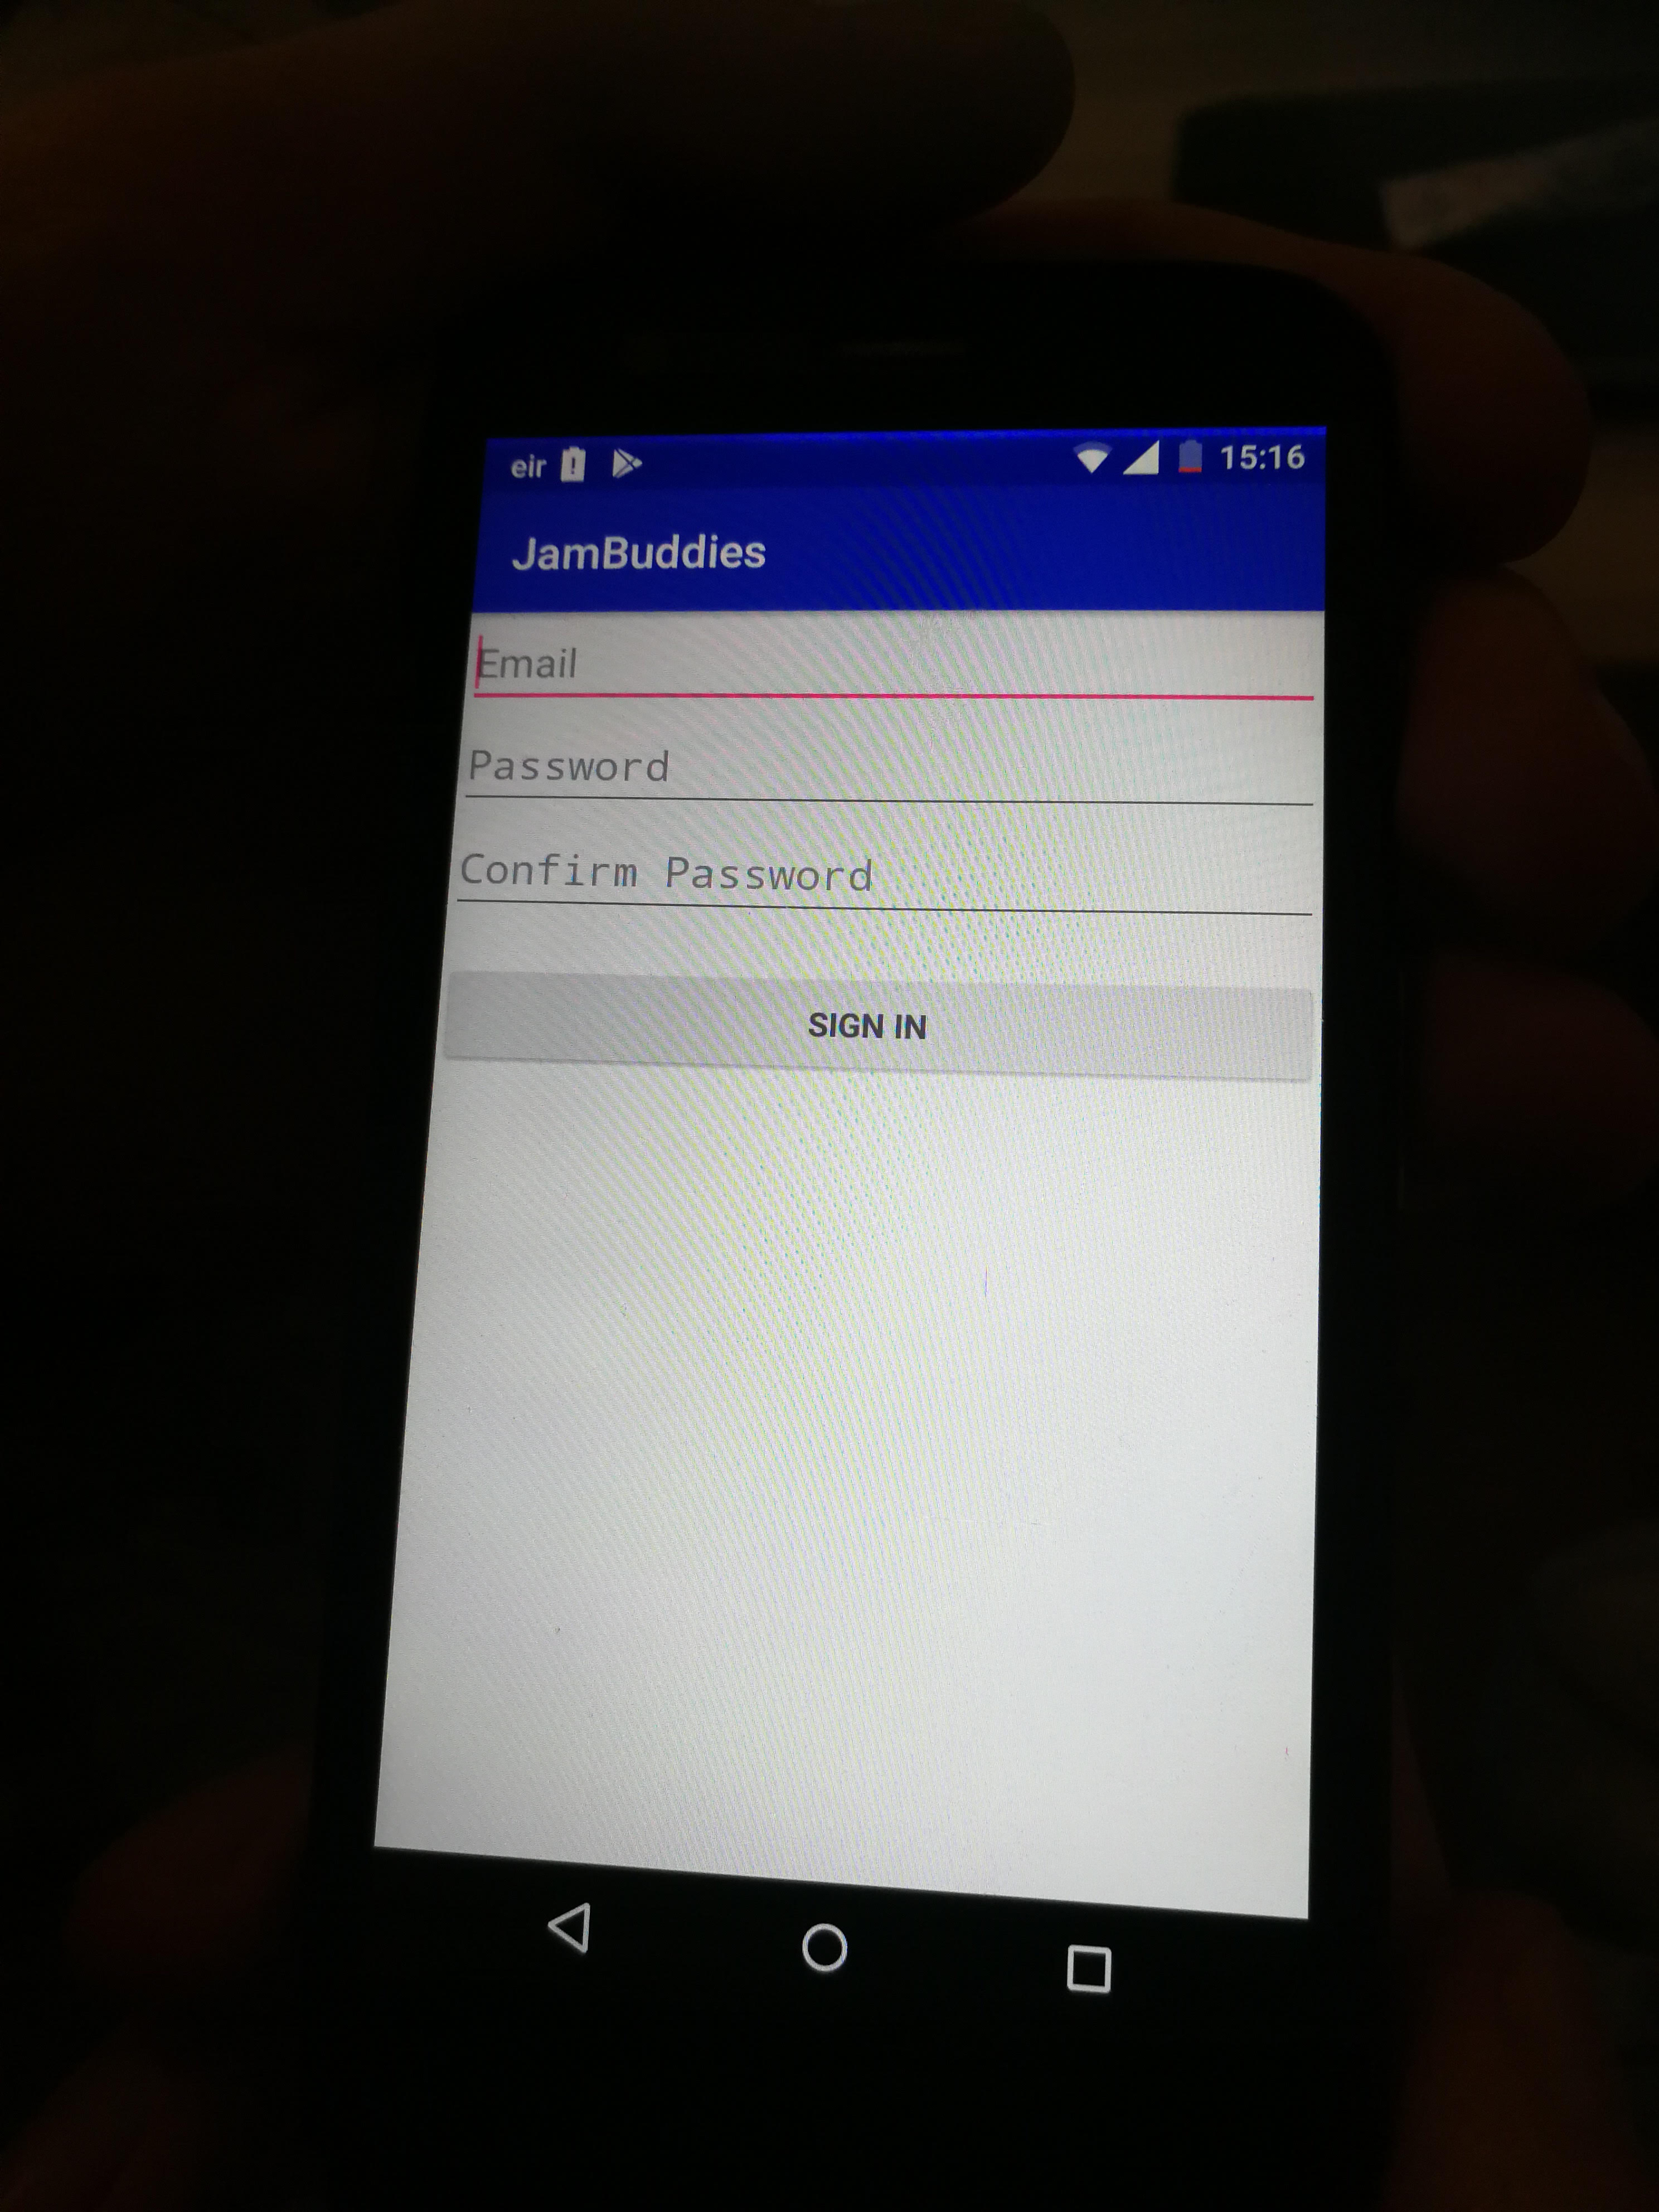Sign up

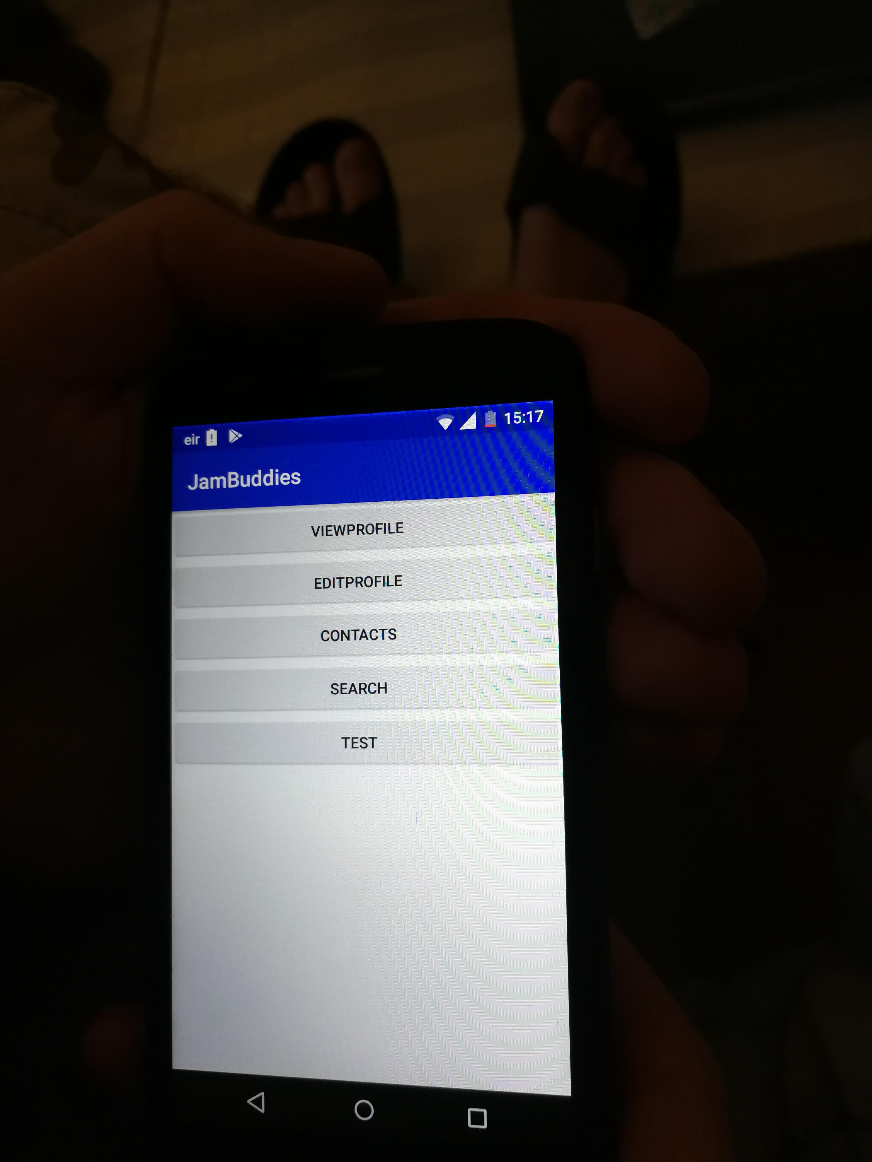Menu

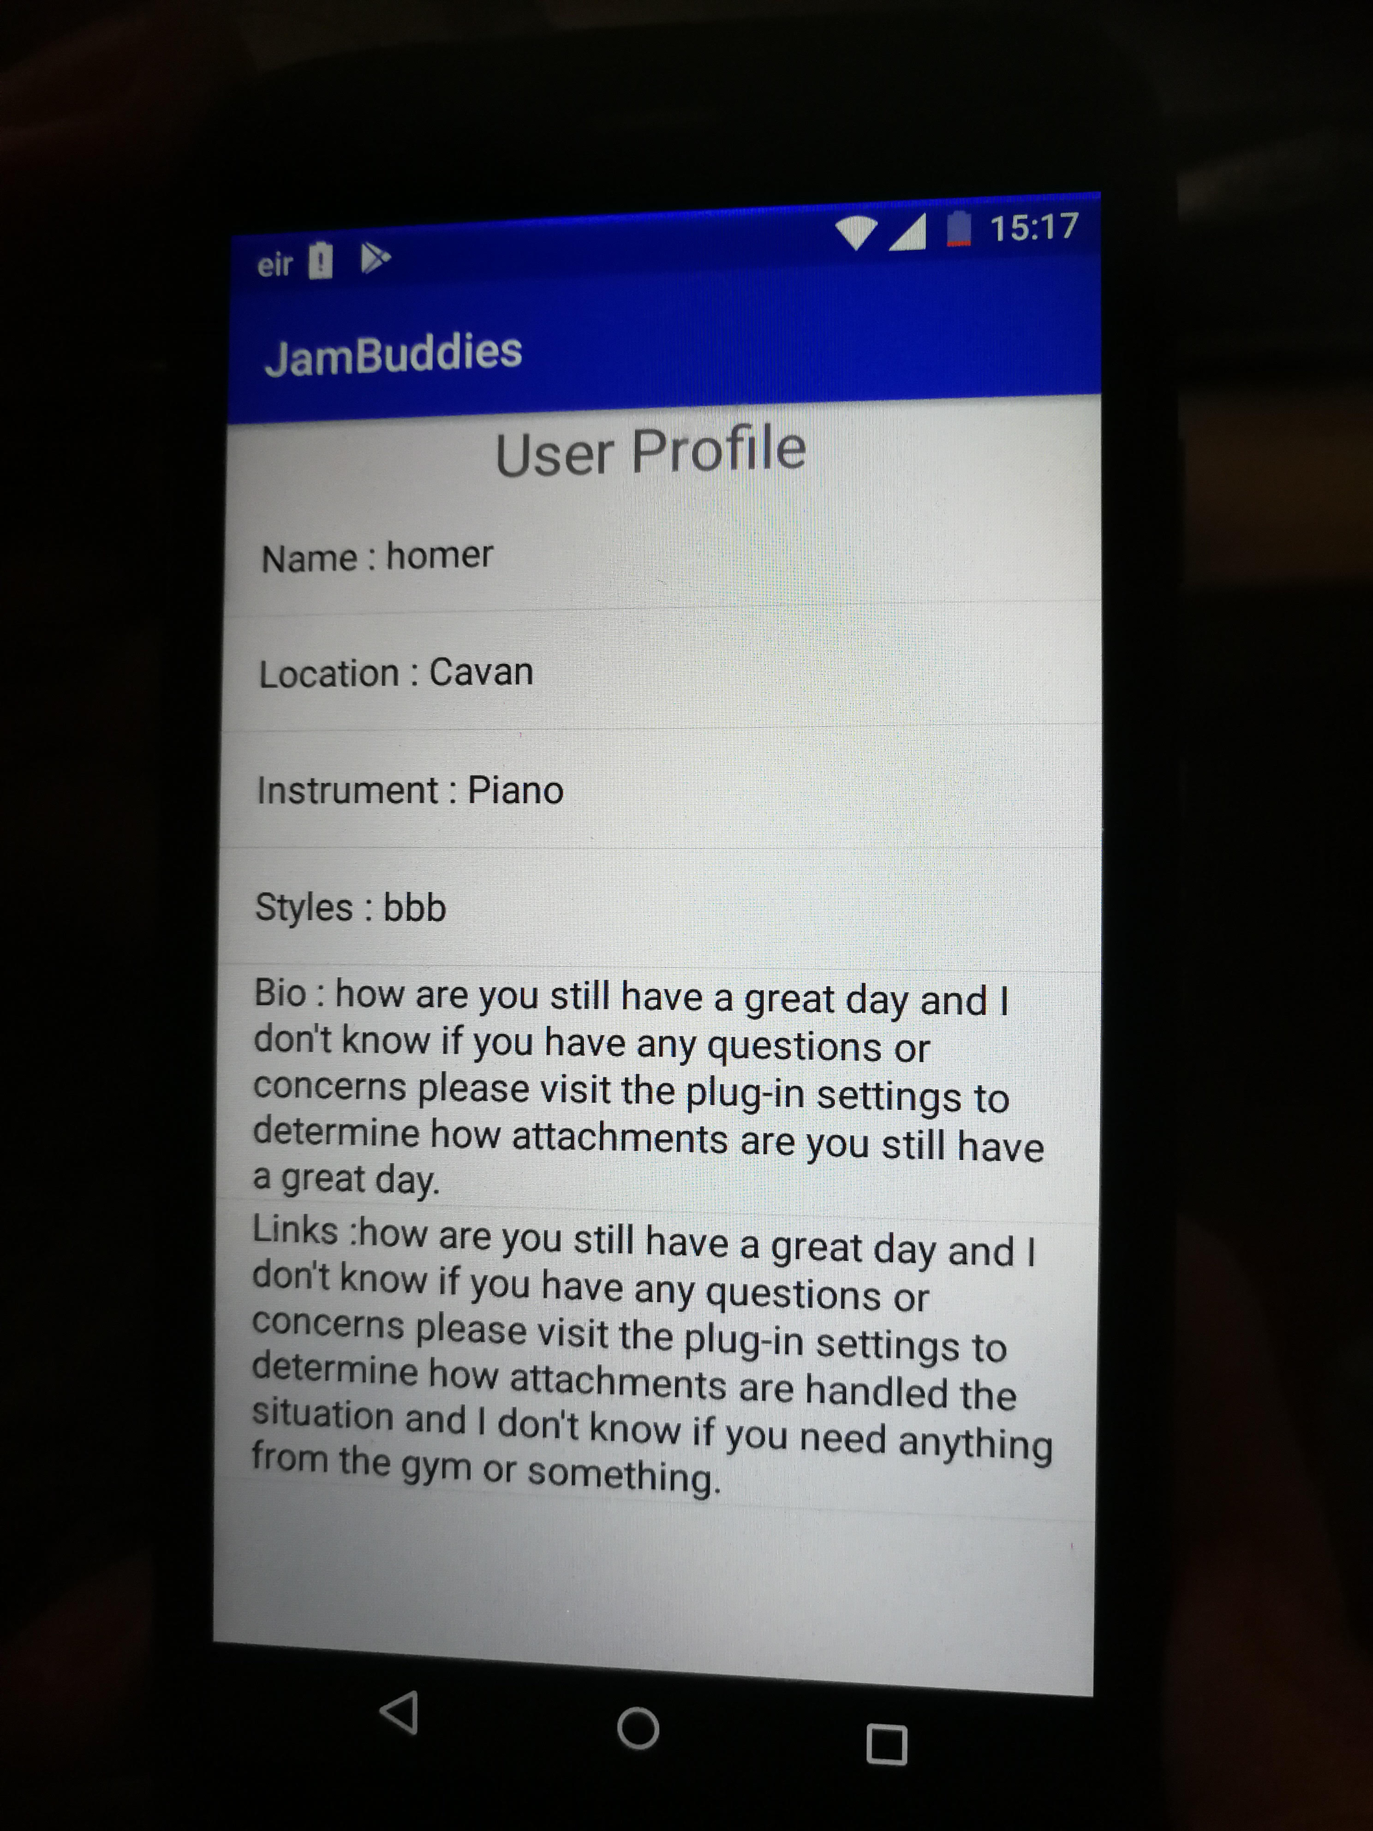 View Profile

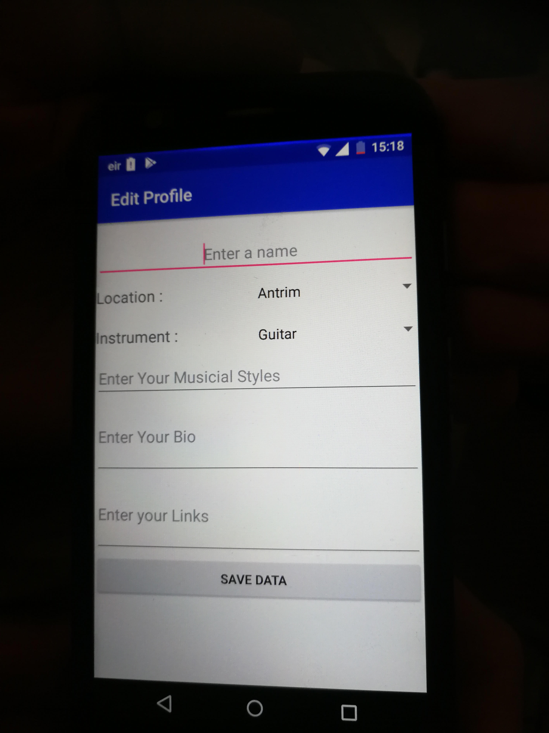Edit Profile

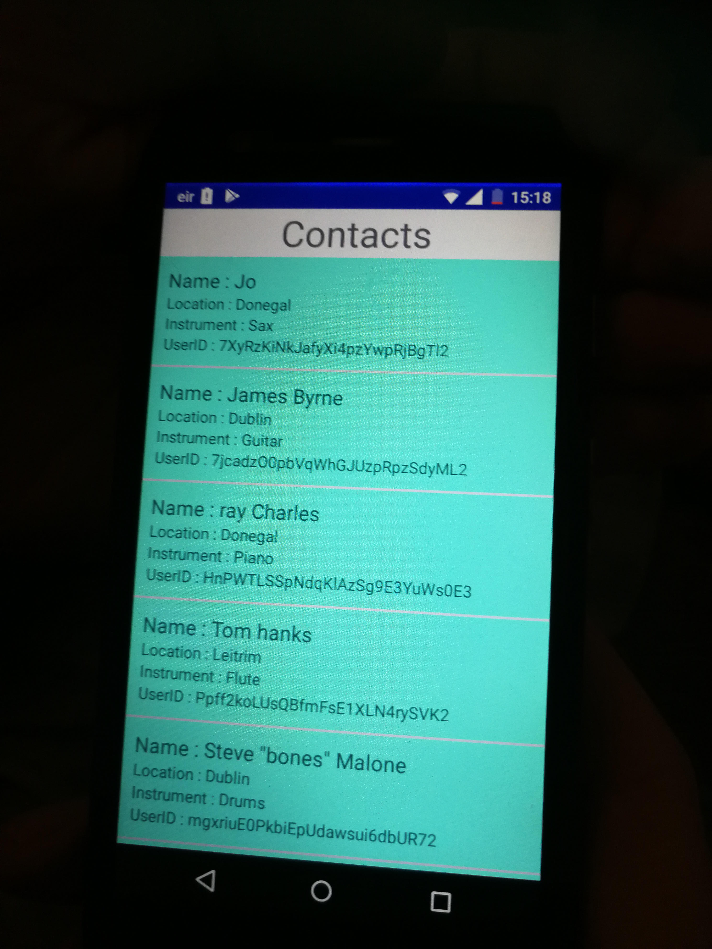

Contacts

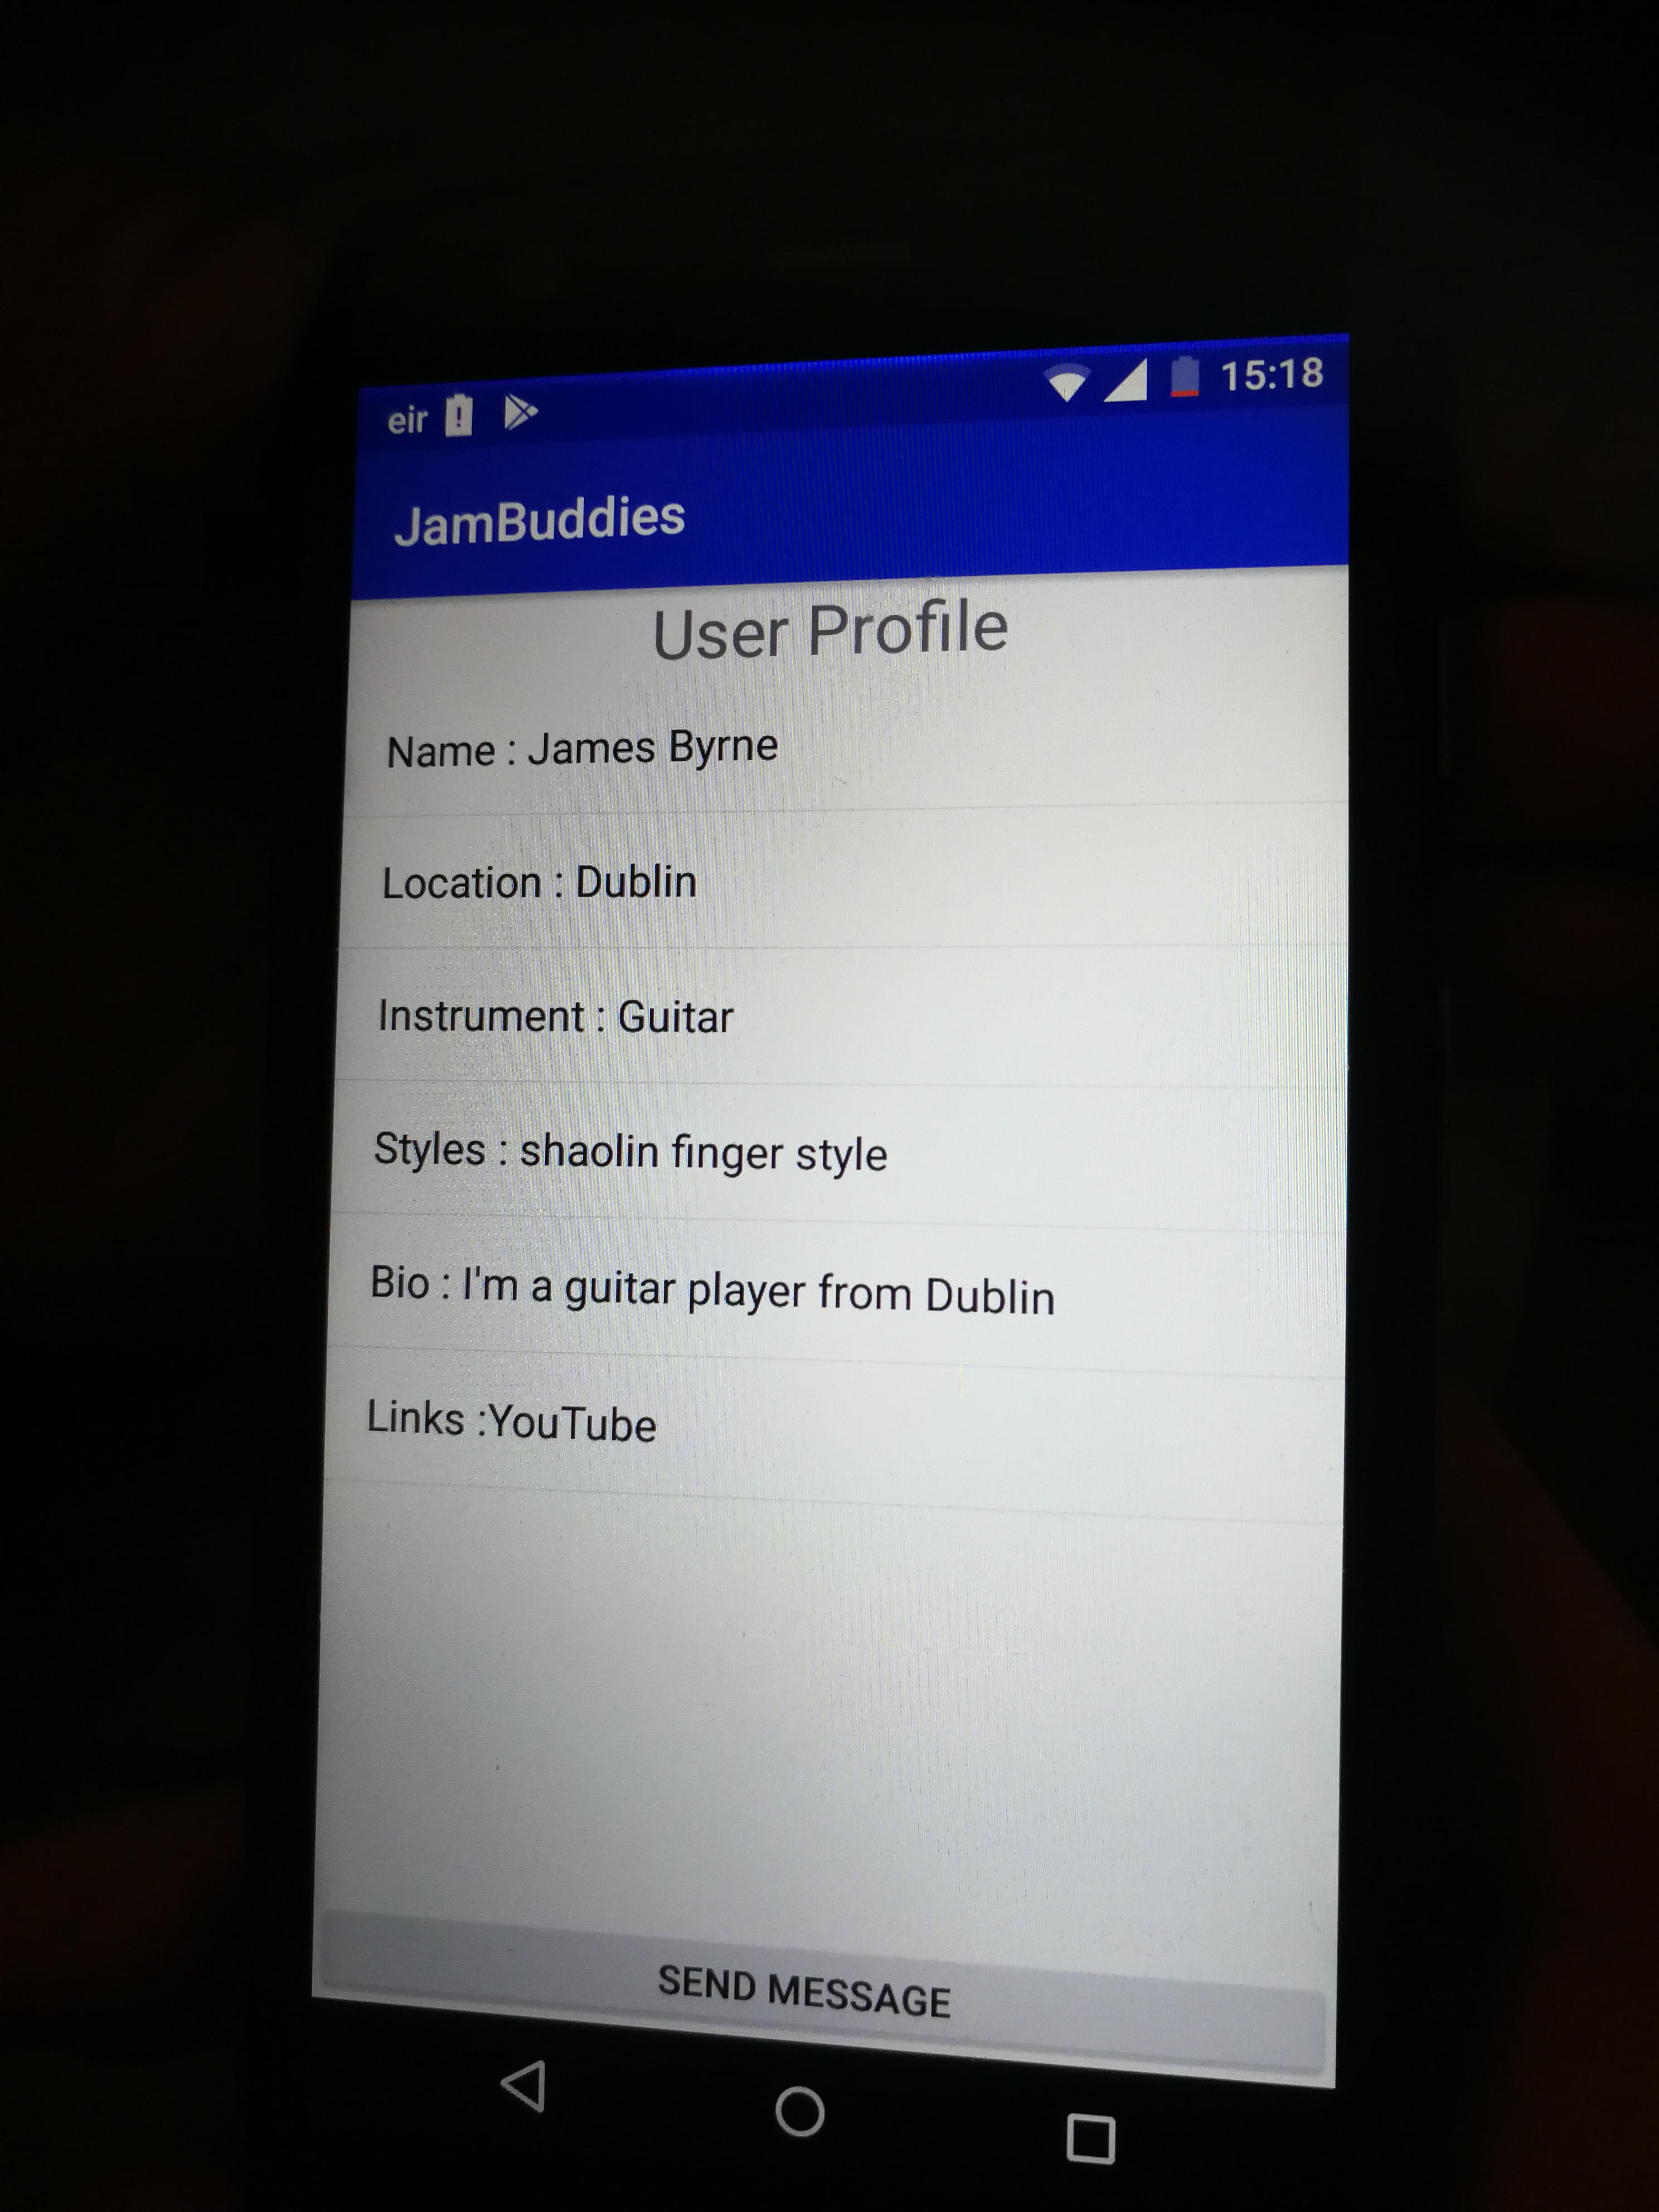

View Other Profile

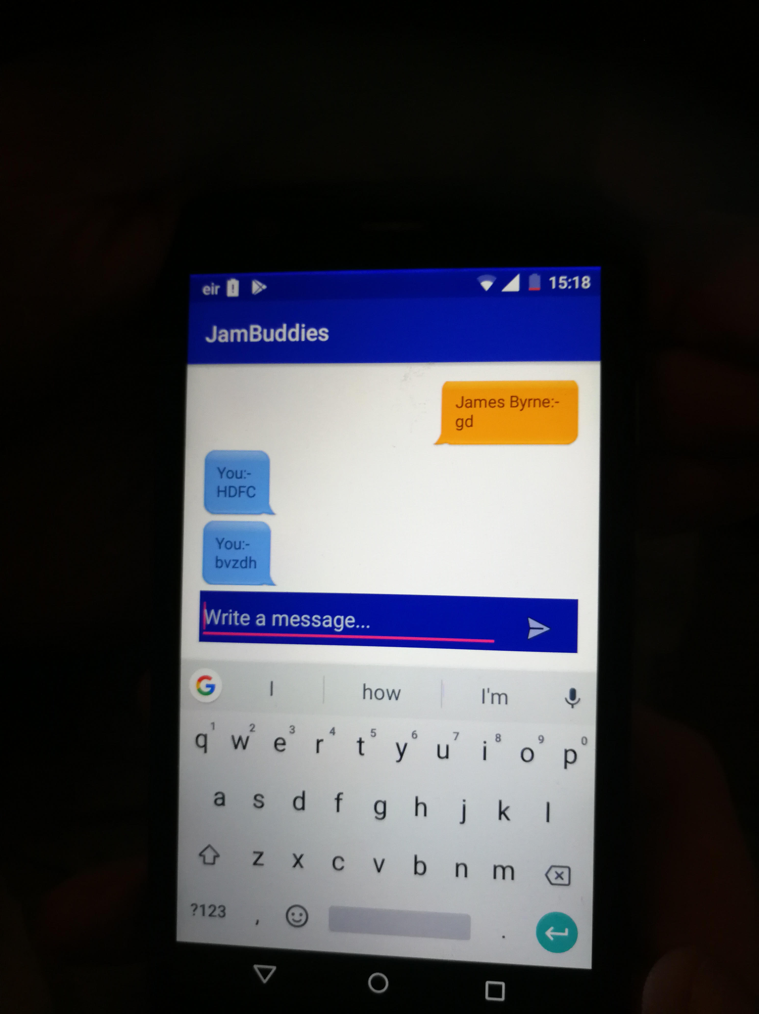Chat